Validar Items no CheckoutRequest.php

**<?php  
  
namespace** CodeDelivery\Http\Requests;  
  
*//UTLIZANDO HttpRequet - Para não dar conflito***use** Illuminate\Http\Request **as** HttpRequest;  
  
**class** CheckoutRequest **extends** Request  
{  
 */**  
 * Determine if the user is authorized to make this request.  
 *  
 \** ***@return*** *bool  
 */* **public function** authorize()  
 {  
 **return true**;  
 }  
  
 */**  
 * Get the validation rules that apply to the request.  
 * //Se exixstir o cupom code e se ele ja foi utilizado  
 \** ***@return*** *array  
 */* **public function** rules(HttpRequest $request)  
 {  
 $rules = [  
 **'cupom_code'** => **'exists:cupoms,code,used,0'** ];  
  
 $this->buildRulesItems(0,$rules);  
 *//VERIFICA SE TEM O ITEMS* $items = $request->get(**'items'**, []);  
 *//FORÇAR SER O ARRAY* $items = !*is_array*($items)?[]:$items;  
 *//VARREDURA DAS REGRAS* **foreach** ($items **as** $key => $val)  
 {  
 $this->buildRulesItems($key, $rules);  
 }  
  
 **return** $rules;  
 }  
  
 */**  
 \** ***@param*** *$key  
 \** ***@param*** *array $rules  
 * Criando validação, personalizada para o array  
 * Pega cada item e adiciona o require  
 */* **public function** buildRulesItems($key, **array** &$rules)  
 {  
 $rules[**"items.**$key**.product_id"**] = **'required'**;  
 $rules[**"items.**$key**.qtd"**] = **'required'**;  
 }  
  
}

Validando Itens Com Cupom Inexistente

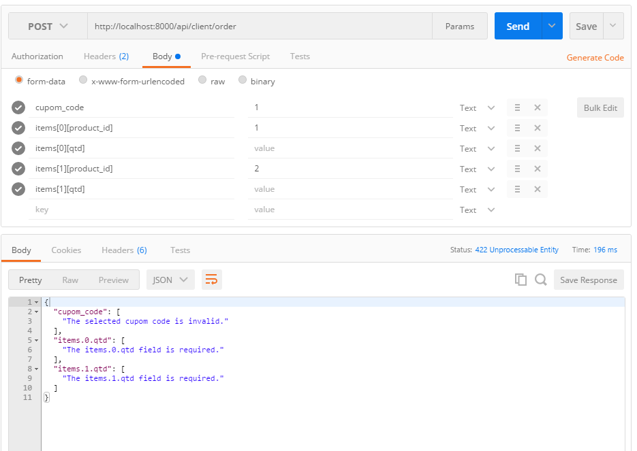

Validando Itens Com Cupom Existente

